PROJECT TITLE
Web Security Scanner Chrome Extension for Real-Time Threat Detection

M VARSHITH REDDY SHASHIDHAR
CYBER SECURITY CYBER SECURITY MENTOR
TA1CS1025123 TEKS ACADEMY
TEKS ACADEMY 9603343287
9390542631

1. Abstract
The rapid growth of internet usage and web-based applications has significantly increased the exposure of users to various cybersecurity threats. Many users access websites daily without verifying their security, making them vulnerable to attacks such as phishing, data interception, and malicious script execution. In this context, there is a strong need for tools that can assist users in identifying potential risks while browsing the internet.
The Web Security Scanner Chrome Extension is developed as a lightweight, real-time solution to analyze the security posture of websites. This browser extension evaluates key security aspects such as the use of HTTPS protocol, presence of Content Security Policy (CSP), number of external scripts, and usage of iframes. These parameters are essential indicators of a website’s security level and can help in identifying potential vulnerabilities.
The extension works by injecting a content script into the active webpage and scanning its structure using Document Object Model (DOM) analysis. The results are then processed and displayed in a user-friendly popup interface. The output includes a list of detected issues along with a risk level classification (Low, Medium, High), making it easy for users to understand the security status of the website.
2. Problem Statement
In today’s digital era, web applications have become an integral part of daily life, ranging from banking and shopping to communication and education. However, not all websites follow proper security standards, which exposes users to various risks. Many websites still operate without secure communication protocols, proper security headers, or safe coding practices, making them vulnerable to cyberattacks.
One of the major challenges is that users are generally unaware of these risks. They may unknowingly enter sensitive information such as passwords or personal data on insecure websites. Traditional security tools, such as antivirus software or web scanners, are often complex, require installation, or do not provide real-time feedback during browsing.
Additionally, existing solutions may not be accessible to non-technical users due to their complexity. There is a clear gap between advanced cybersecurity tools and user-friendly solutions that can provide immediate insights into website security.
The problem addressed in this project is to design a simple, efficient, and real-time system that can analyze a webpage and alert users about potential security risks. The solution must be lightweight, easy to use, and capable of providing meaningful feedback without requiring technical expertise.

3. Project Objectives
The primary objective of this project is to develop a browser extension that enhances user awareness regarding web security. The extension is designed to analyze websites in real time and provide users with insights into potential vulnerabilities.
One of the key objectives is to detect insecure communication protocols, specifically identifying whether a website uses HTTP instead of HTTPS. Secure communication is essential for protecting user data, and detecting its absence is a critical feature of the extension.
Another objective is to identify the presence or absence of security mechanisms such as Content Security Policy (CSP). CSP plays an important role in preventing cross-site scripting (XSS) attacks, and its absence can indicate potential security risks.
The project also aims to detect external scripts and iframe elements, which can sometimes introduce vulnerabilities if not properly managed. By analyzing these elements, the extension provides a more comprehensive view of the webpage’s security.
In addition to detection, the project focuses on presenting results in a clear and understandable format. The use of color-coded indicators and risk levels ensures that users can quickly interpret the results.
Finally, the project aims to provide a scalable foundation for future enhancements, such as advanced threat detection, phishing analysis, and integration with security APIs.

4. Project Scope
The scope of the Web Security Scanner Chrome Extension is limited to client-side analysis of webpages within the browser environment. The extension focuses on identifying basic security indicators that can be detected through DOM inspection and browser APIs.
The project includes detection of insecure HTTP connections, missing Content Security Policy, external script loading, and iframe usage. These checks provide a basic understanding of the security posture of a website and help users identify potential risks.
The extension operates in real time and provides immediate feedback through a popup interface. It is designed to be lightweight and does not significantly impact browser performance. The simplicity of the tool ensures that it can be used by a wide range of users without requiring technical knowledge.
However, the project does not include advanced security features such as server-side vulnerability scanning, penetration testing, or deep malware analysis. It does not replace professional security tools but serves as an awareness and educational tool.
The scope can be extended in the future to include additional features such as phishing detection, SSL certificate validation, and integration with threat intelligence services.

5. Tools and Technologies Used
The development of this project involves a combination of web technologies and browser-specific APIs. The primary technology used is the Google Chrome Extension API, which provides the necessary framework for building and managing browser extensions.
JavaScript is used as the main programming language for implementing the logic of the extension. It enables DOM manipulation, event handling, and communication between different components of the extension. The content script uses JavaScript to analyze the webpage and extract relevant security information.
HTML is used to design the structure of the popup interface, while CSS is used to style the interface and improve its visual appearance. The use of simple and clean design ensures that the extension is easy to use and visually appealing.
Visual Studio Code is used as the development environment due to its flexibility, extensions, and support for web development. The Chrome browser is used for testing and debugging the extension using developer tools.
Overall, the combination of these technologies allows for efficient development and deployment of the extension while ensuring performance and usability.

6. Deliverables
The project deliverables include all components required to demonstrate the functionality and implementation of the Web Security Scanner Chrome Extension. The primary deliverable is the fully functional browser extension that can be installed and used within the Chrome browser.
The source code is another important deliverable, which includes files such as manifest.json, popup.html, popup.js, and content.js. These files collectively define the structure, behavior, and functionality of the extension.
In addition to the extension and source code, documentation is provided to explain the design, implementation, and usage of the project. This documentation includes details about the features, technologies used, and instructions for installation and testing.
Screenshots of the extension in action are also included as part of the deliverables. These screenshots demonstrate the functionality of the extension and provide visual evidence of its working.
Finally, a presentation is prepared to explain the project in a structured manner. The presentation includes slides covering the introduction, problem statement, objectives, implementation, and conclusion of the project.

7. Project Implementation
The implementation of the Web Security Scanner Chrome Extension is carried out in a structured manner, starting from environment setup to final testing. Each step is documented with corresponding outputs to ensure clarity and reproducibility.

Step 1: Environment Setup
The development process begins with setting up the required environment. A project folder named web-security-extension is created on the system. A code editor such as Visual Studio Code is used to manage and edit the project files. The Google Chrome browser is used for testing the extension.
The folder structure is organized to include all necessary files such as manifest.json, popup.html, popup.js, and content.js.
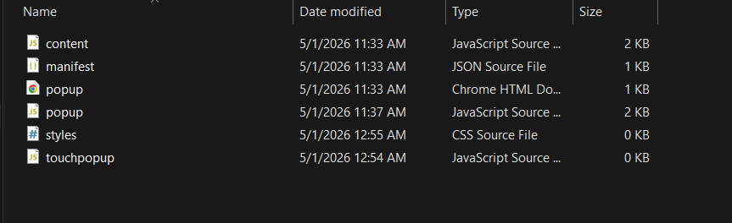

Step 2: Creating Manifest File
The manifest.json file is the core configuration file of the Chrome extension. It defines the extension name, version, permissions, and links to scripts and UI components.
The manifest version 3 is used to comply with modern Chrome extension standards. Permissions such as activeTab and scripting are included to allow interaction with web pages.
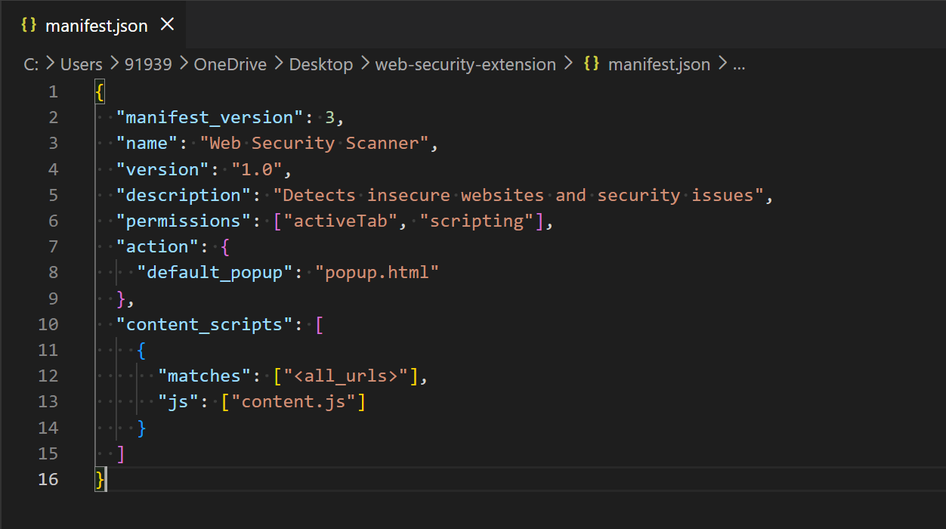

Step 3: Designing Popup Interface
The popup interface is created using HTML. It provides a simple user interface containing:
- Title: “Security Scan”
- Button: “Scan Page”
- Result display section
CSS is applied to enhance the layout, spacing, and readability of the interface.
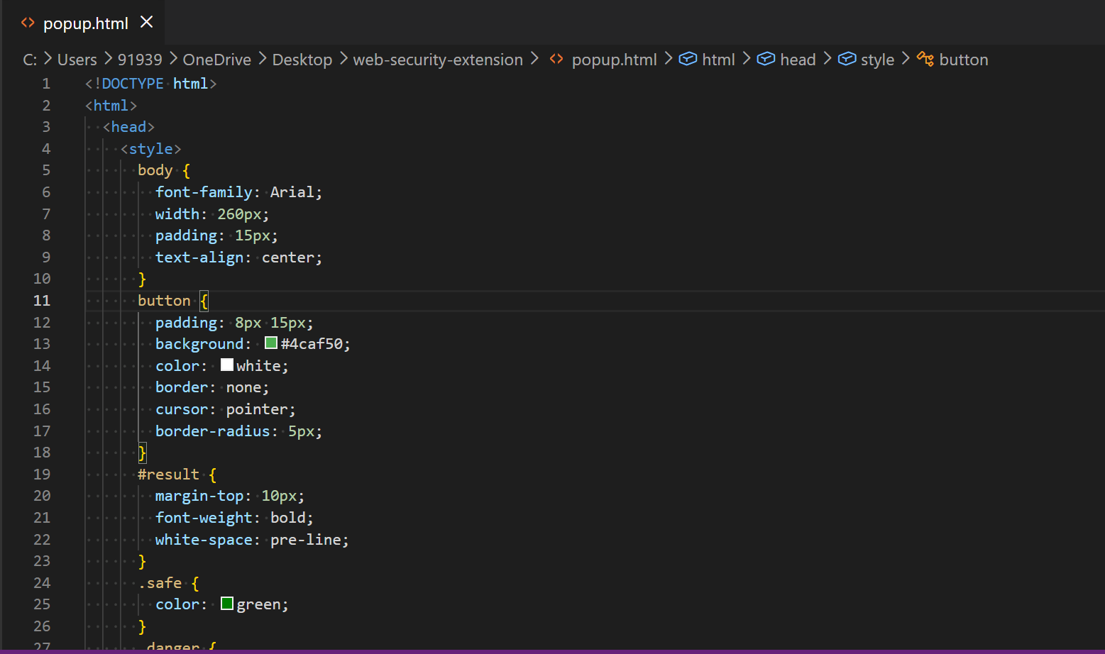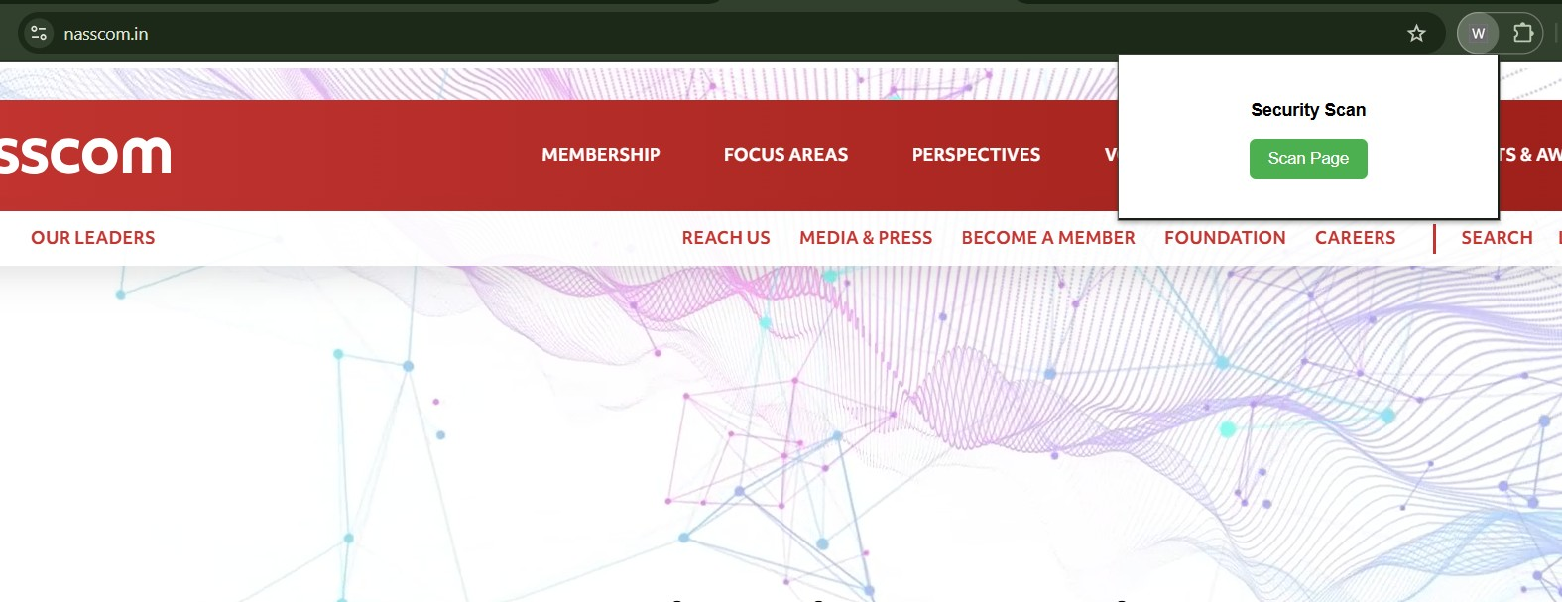

Step 4: Implementing Popup Logic
JavaScript is used in popup.js to handle user interaction. When the user clicks the “Scan Page” button, a message is sent to the content script.
The script retrieves the active tab and communicates using Chrome messaging APIs. It also handles displaying results dynamically inside the popup.
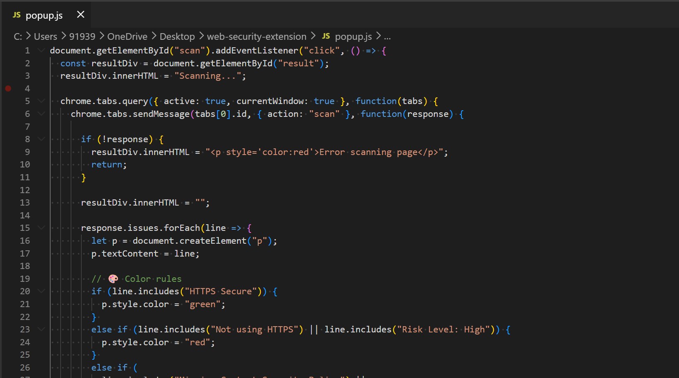

Step 5: Developing Content Script
The content.js file is responsible for analyzing the webpage. It is injected into the active tab and performs the following checks:
- Detects whether the website uses HTTPS
- Checks for missing Content Security Policy (CSP)
- Identifies external scripts
- Counts iframe elements
The script collects these details and sends them back to the popup.
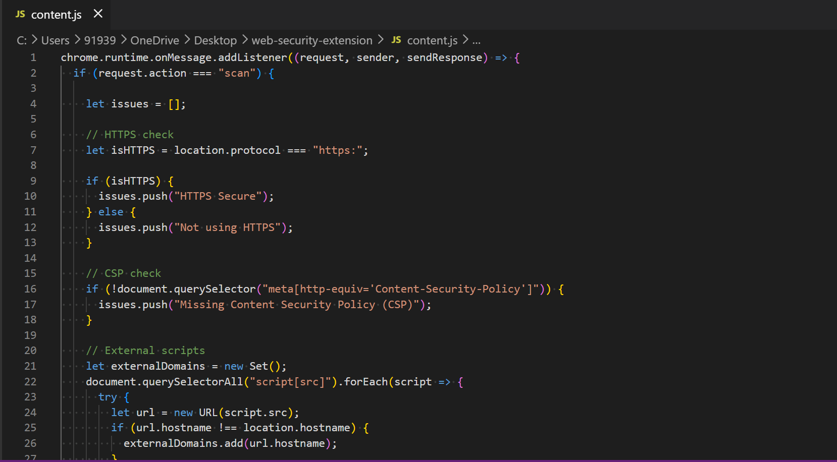

Step 6: Implementing Security Checks
Different security checks are implemented as part of the content script:
- HTTPS Check: Verifies secure connection
- CSP Check: Detects missing security headers
- External Scripts: Counts third-party scripts
- Iframe Detection: Identifies embedded frames
These checks help evaluate the security posture of the webpage.
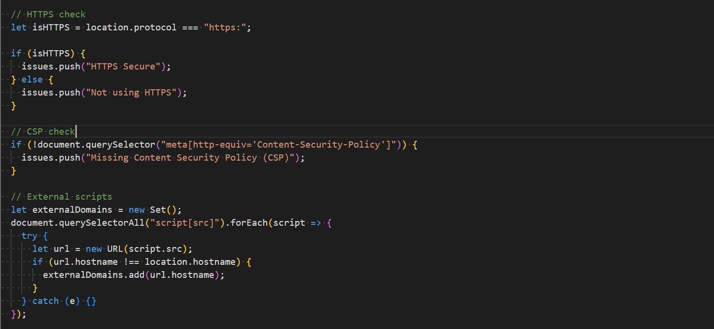

Step 7: Risk Level Calculation
A risk scoring mechanism is implemented to classify the severity of detected issues. Each issue is assigned a weight, and the total score determines the risk level:
- Low Risk
- Medium Risk
- High Risk
This classification helps users quickly understand the seriousness of the vulnerabilities.
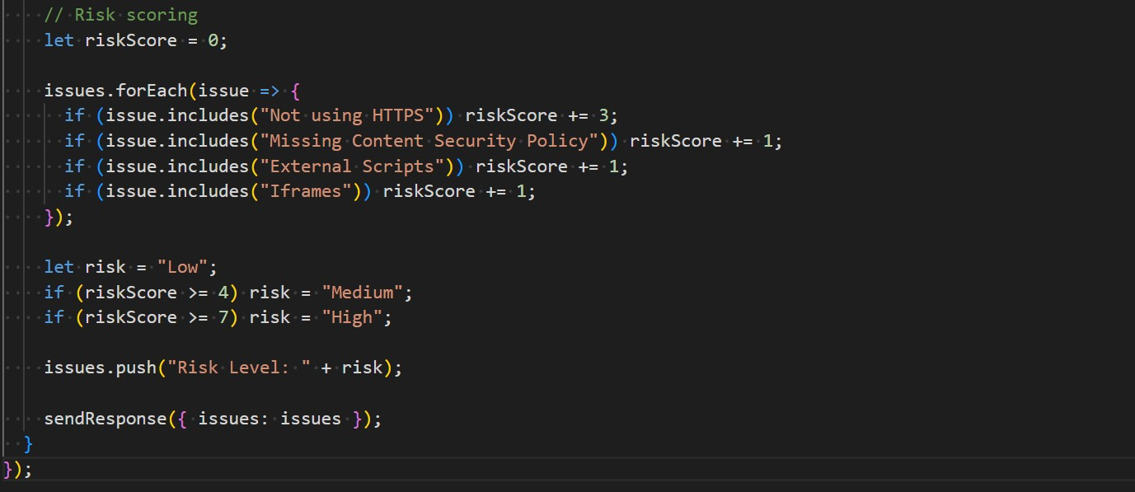

Step 8: Displaying Results with Color Coding
The results are displayed in the popup using color-coded text:
- 🟢 Green → Secure (HTTPS / Low Risk)
- 🟡 Yellow → Warnings (CSP, external scripts, iframes)
- 🔴 Red → Critical issues (No HTTPS / High Risk)
Each line is displayed separately to improve readability.
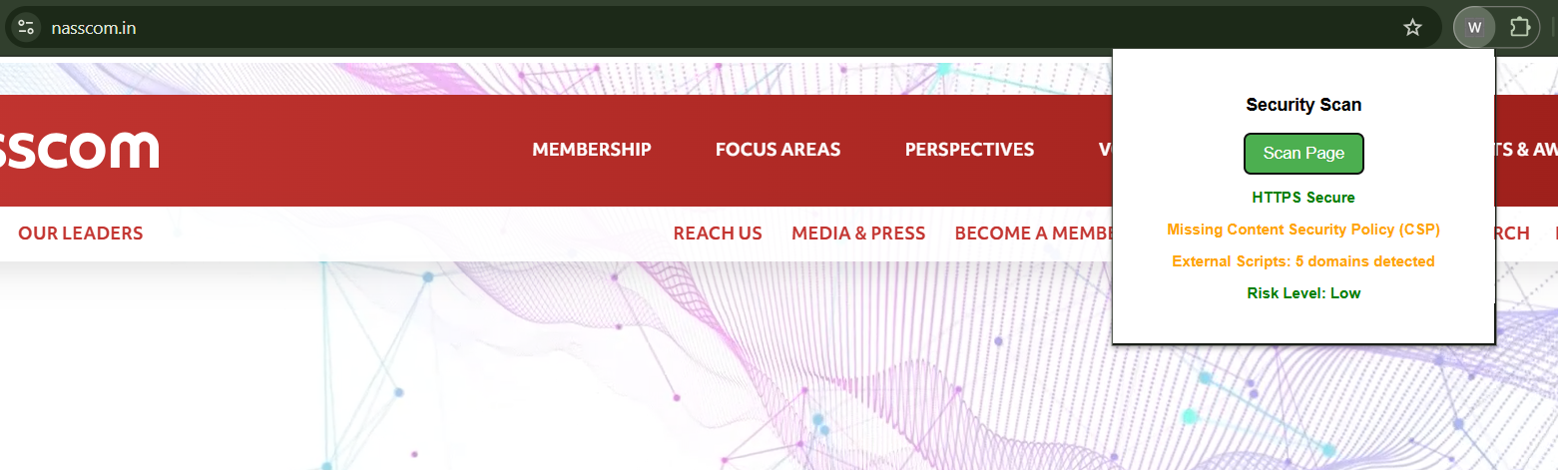

Step 9: Loading Extension in Chrome
The extension is loaded into Chrome using Developer Mode:
- Open Chrome Extensions page
- Enable Developer Mode
- Click “Load Unpacked”
- Select project folder
The extension icon appears in the browser toolbar.

Step 10: Testing the Extension
The extension is tested on multiple websites to verify functionality. Different scenarios are analyzed:
- Secure HTTPS websites
- Websites without CSP
- Websites with multiple external scripts
- Pages containing iframes
The extension correctly identifies issues and displays results.
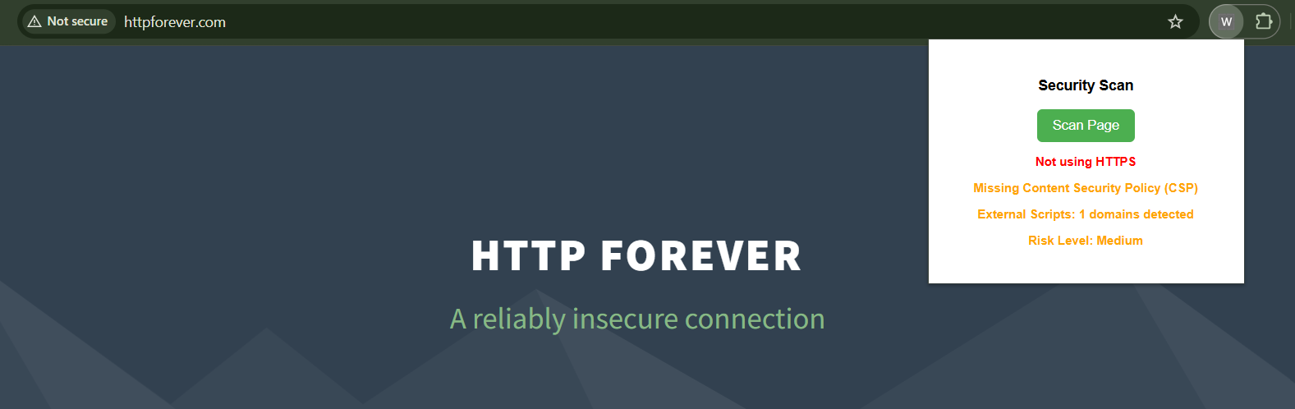
Step 11: Debugging and Fixing Issues
During development, debugging is performed using Chrome Developer Tools. Issues such as message passing errors, script injection failures, and UI bugs are resolved.
Console logs are used to track execution flow and ensure correct behavior.

Step 12: Final Output
After successful testing and debugging, the extension provides clean and structured output with proper risk classification and color coding.
The final system is stable, user-friendly, and ready for demonstration.
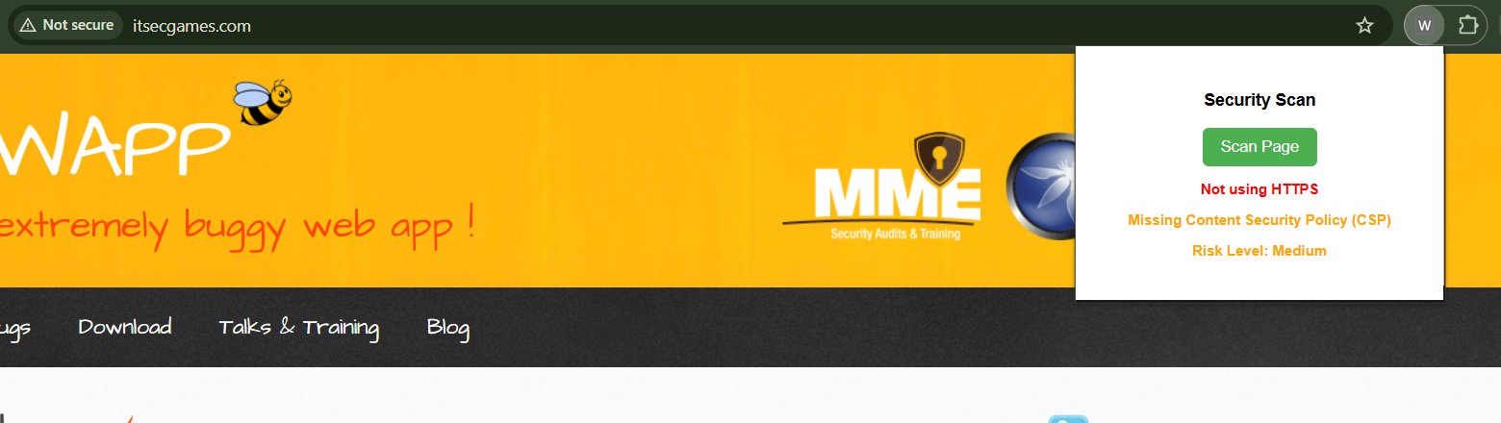 8. Conclusion
The Web Security Scanner Chrome Extension successfully demonstrates the ability to analyze and identify basic web security issues in real time. It provides a simple and effective solution for improving user awareness regarding website security.
The project highlights the importance of secure browsing practices and shows how browser extensions can be used to enhance security without requiring complex tools. The use of color-coded indicators and risk levels makes it easy for users to understand the results.
Although the current implementation focuses on basic security checks, it provides a strong foundation for future enhancements. Additional features such as phishing detection, SSL certificate validation, and integration with security APIs can further improve the functionality of the extension.
Overall, this project serves as a valuable learning experience in web development and cybersecurity. It demonstrates the practical application of theoretical concepts and provides a useful tool for promoting safer browsing habits.

